**Rotary International’s CEO lauds Ukrainian civil society**

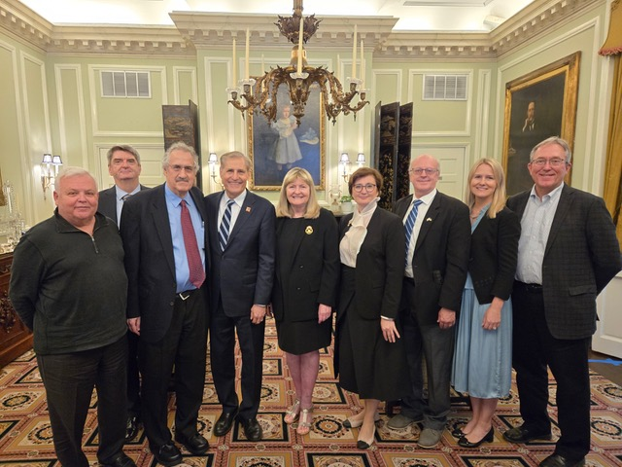

*Keynote speaker John Hewko, CEO of Rotary International (4th from left) with board members of The Washington Group and Kateryna Smagliy (Counselor, Political Affairs and Public Diplomacy, Embassy of Ukraine) [Credit: The Washington Group]*

WASHINGTON, D.C. -- The Washington Group (TWG), an association of Ukrainian-American professionals, hosted John Hewko, CEO of Rotary International, at its latest distinguished speaker series luncheon held at the historic DACOR Bacon House in the nation’s capital. Laryssa Courtney, President of TWG, opened the event, welcoming participants and noting that the organization that she leads is celebrating its 40th anniversary.

Also addressing the audience was Denys Sienik, Deputy Chief of Mission of the Embassy of Ukraine in the USA, who commended TWG for the work it has done over the decades in terms supporting Ukraine and the strengthening of US-Ukraine relations, including through advocacy work aimed at bolstering U.S. assistance for Ukraine in its current battle against Russia’s genocidal full-scale invasion. Mr. Sienik was deeply impressed by TWG’s activities as reflected in its archival material noting that both Zbigniew Brzezinski ([Video](https://imemories.us/4fU2Ot3)) and Viacheslav Briukhovetsky ([Video](https://imemories.us/3YSy3xx)) addressed TWG, with Briukhovetsky and Leonid Kravchuk later reestablishing the Kyiv-Mohyla Academy. The Washington Group’s efforts are still very much needed, “do not stop” he said. Mr. Sienik also expressed appreciation for the organization’s promotion of Ukrainian arts through TWG’s Cultural Fund’s concert series. He also thanked TWG for sponsoring interns at the Embassy of Ukraine under the auspices of its Fellowship Fund.

Alexa Chopivsky, TWG Events Director, introduced the keynote speaker of the event – John Hewko, the CEO of Rotary International, a global service organization with headquarters in Evanston, Illinois, which works on such challenges as fighting disease, supporting education, protecting the environment and fostering economic development at the community level. He described various aspects of the activities of Rotary which has 45,000 local clubs with 1.2 million members, the majority of them outside of the United States, including in Ukraine.

Mr. Hewko opened his remarks by recalling that the last time he addressed TWG was in 1991 just in the aftermath of Ukraine’s independence.

Mr. Hewko offered a historical perspective to offset in part the sadness and anger resulting from the current state of war. Having served in Ukraine as the executive secretary of the International Advisory Council to the Ukrainian Parliament in 1991-1992 and then as founding and managing partner for Baker McKenzie (1992-1996), he described the hesitant steps Ukraine took in declaring its independence, the deep divisions in the country, and how there were few functioning institutions at that time. The current war has unified the country. Ukrainian language is now prominent. As an example, prior to the war, Rotary meetings in eastern Ukraine were typically conducted in Russian and now are conducted exclusively in Ukrainian. Ukraine is now accepted in the world as a legitimate country with a history and a language. It is no longer confused with Russia (except by Putin). For the first time in history Ukraine has an army that can hold its own. Ukraine after the war will be orientated toward the West.

Mr. Hewko emphasized the crucial role of civil society in all aspects of the current war in Ukraine from initial humanitarian assistance to future role in the reconstruction of Ukraine after the end of the war. When the war began Rotarians spontaneously mobilized. Seventeen million dollars were collected within days. Hundreds of Rotarians set up capability to help refugees. Eighty million dollars have been collected up to now. Civil society is nimble and can fill in gaps that government actions leave.

Post war reconstruction will take a long time. Complicating factors include: Ukraine’s demographic crisis, the social tension between those who stayed in Ukraine vs. those who fled abroad; tension between those who served in the army vs. those who did not.

Private sector has the resources needed for reconstruction. For these resources to be effectively deployed the most important factor will be the fight against corruption and the implementation of rule of law. Joining the European Union and meeting its entry requirements is crucial in the fight against corruption. Civil society needs to act both as a watchdog overseeing Government efforts at reconstruction and as a sled dog actively and directly engaged in the reconstruction effort. A Code of Conduct for organizations engaged in these efforts was signed in Rzeszow, Poland. Mr. Hewko signed as the representative of Rotary.

In the final segment of his speech Mr. Hewko noted that after World War 2 Germany and Japan underwent profound self-examination and transitioned to becoming normal countries. Russia has not. For Russia to become a normal country Ukraine has to defeat Russia on the battlefield.

The Biden policy of providing Ukraine with just enough aid for it not to lose will in fact result in Ukraine losing. After a frozen contact agreement Ukraine will permanently lose Russian occupied territories because anything Ukrainian in those territories will be purged by the Russian regime and Russians or Central Asians will be relocated on these territories. And Russia will remain a permanent threat.

*Reference:*

[*https://www.rotary.org/en/about-rotary*](https://www.rotary.org/en/about-rotary)